# Findings

**Variation of Revenue Over Time**

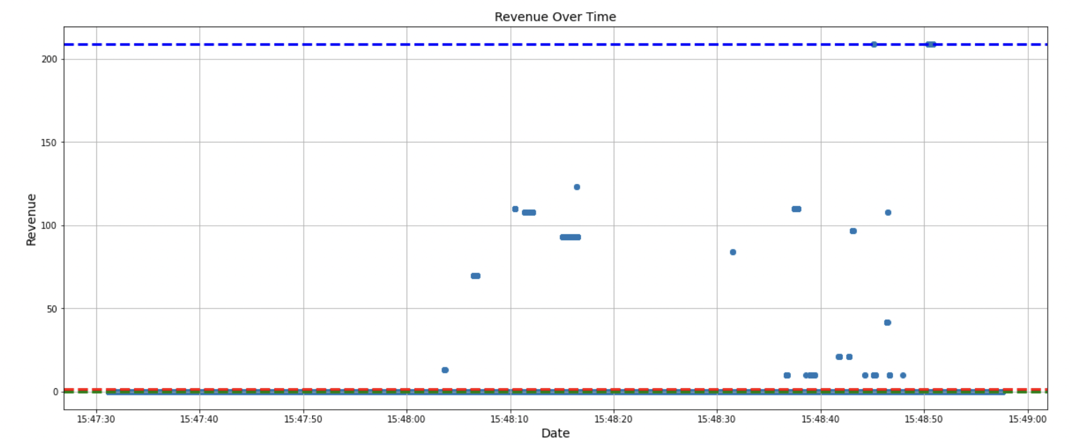



### Revenue Per Product Category





### Website Performance Across Operating Systems

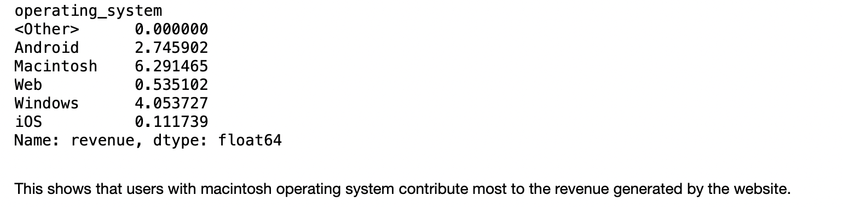

**Measuring Performance based on Events**



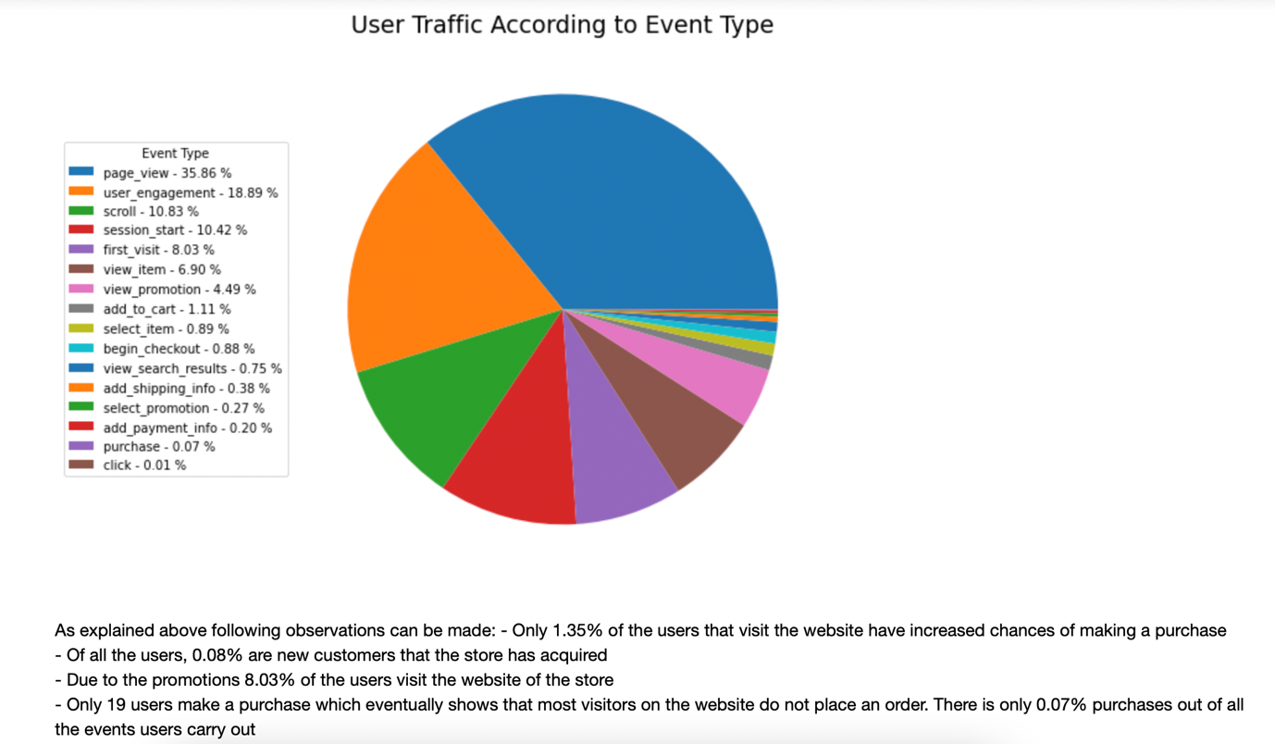

## Conversion Rate Analysis

This section will judge conversion of events on the website to purchases to assess the performance of the store

### Overall Conversion rate



### Conversion Rates According to Location

#### Location: Continent

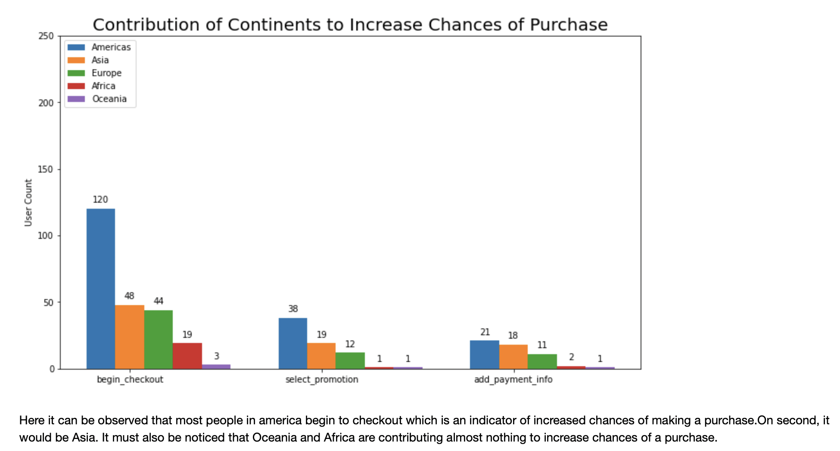

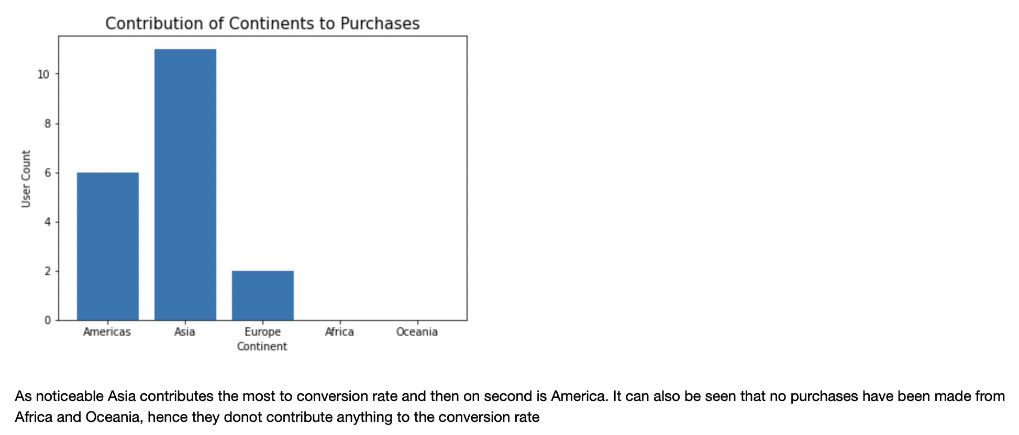

#### Location: Country

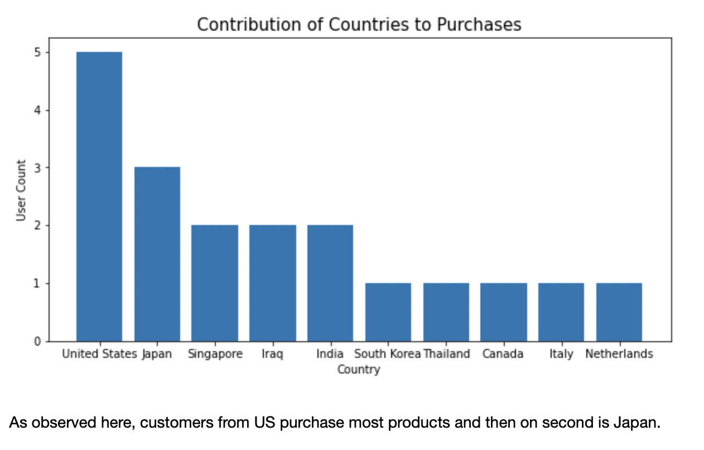

Location: Region

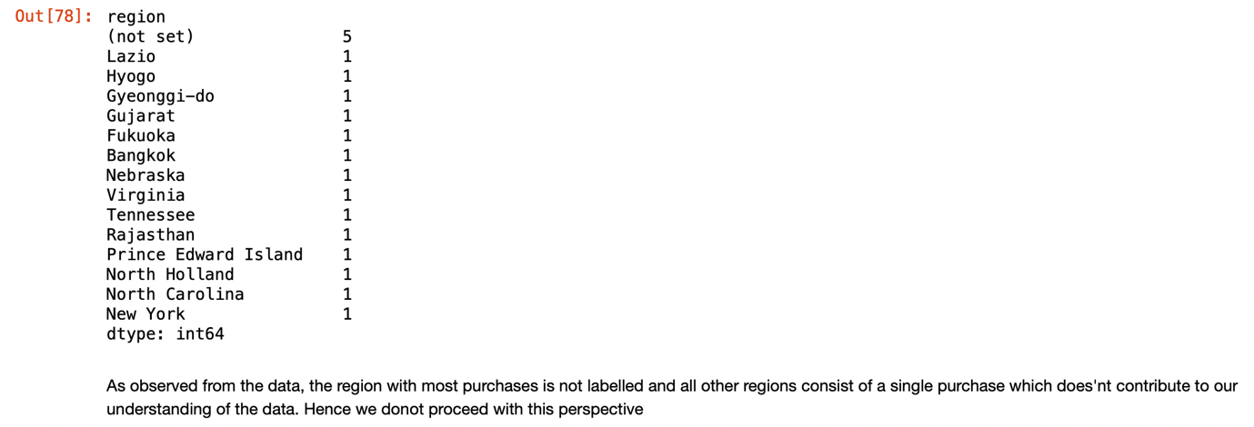

### Conversion Rates According to Mediums and Sources

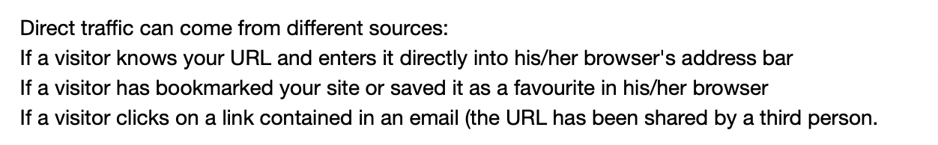

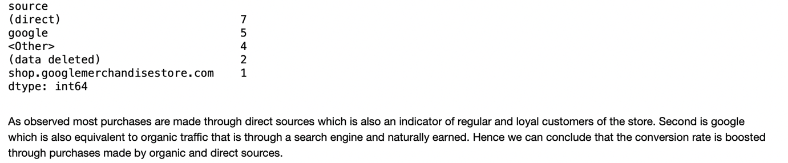

## User Traffic/Engagement Analysis

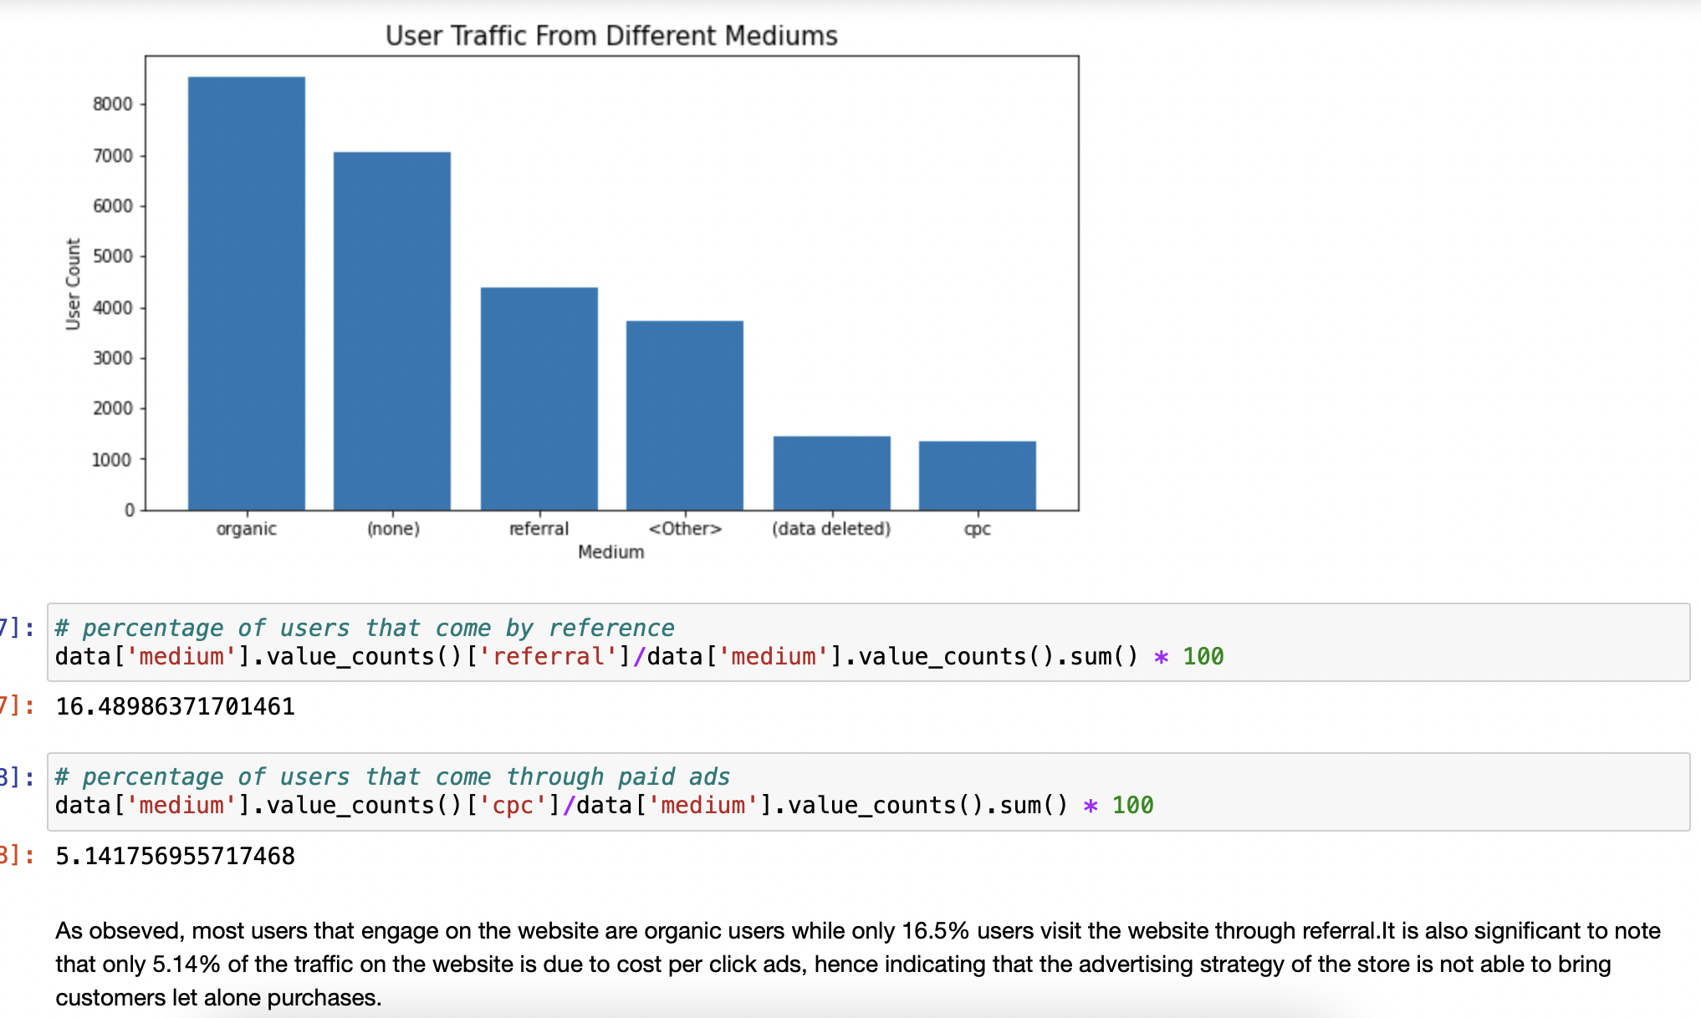

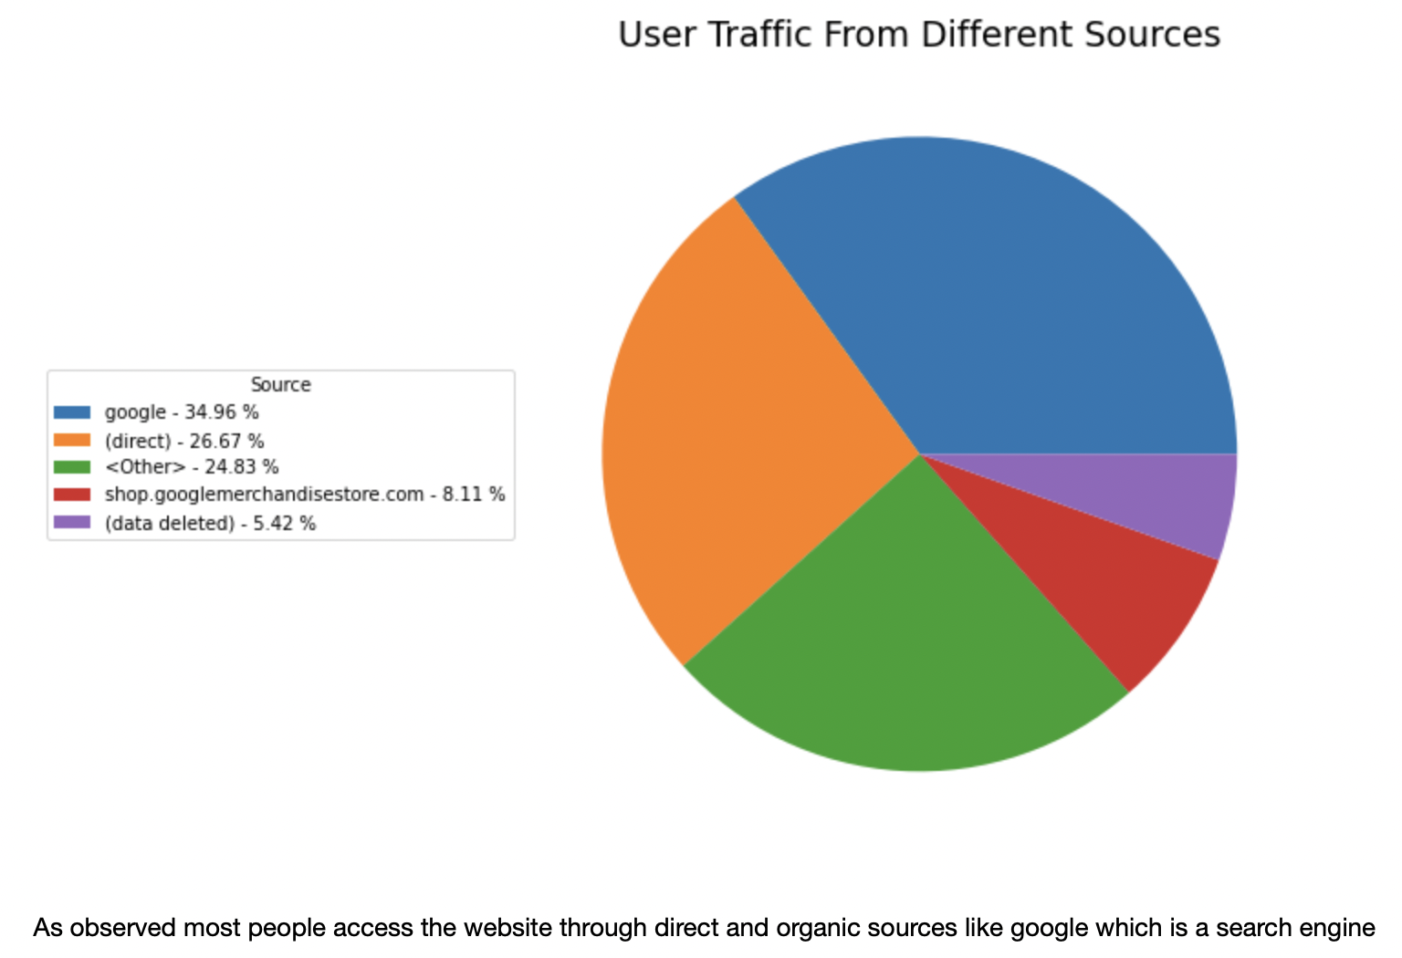

## Mobile Optimization

Mobile optimization refers to the process of designing and adapting a website, application, or digital content to provide an optimal and seamless user experience on mobile devices, such as smartphones and tablets. It involves optimizing the layout, design, functionality, and performance of the digital asset to ensure it is easily accessible, usable, and visually appealing on smaller screens with touch-based interactions.  
  
Here we will analyse data to see what needs to be done when it comes to mobile optimization

